John Cohen and Brandon Domash

Econ 460

Project Report

In selecting a variable, we ultimately aimed to forecast something that would be interesting, as well as relevant to what is occurring in the world today. We settled on forecasting the number of employees in the US mining and logging industry (All Employees: Mining and Logging as reported by the U.S. Bureau of Labor Statistics), which was a big point of contention in the 2016 election, especially Donald Trump, who constantly pandered to these industries during his campaign. Since the election, the number of employees in this industry have steadily increased, from 646,000 to 756,000 employees, causing the president to boast about his great successes; however, we were curious about a slightly longer term forecast of these numbers. As for the industry over time, the number of employees saw huge fluctuations from the data was first recorded in the 1940s until the 1950s when it began to stabilize, which is likely due to poor data collections. The number of employees saw a boom throughout the 1970s and into the early 1980s, when it took a sharp decline in 1982 all the way until 2003. In the early 2000s, there have been a few periods of ups and down, but nothing to conclude that these jobs are coming back for good.

After noticing some of the initial behavior of the data, we aimed to try and come up with a forecast stronger than Trump’s baseless claims that the industry will continue to grow forever under his watch. We first looked to see if there was a trend component of this times series and concluded that there was no blatant observable trends in the data. Next, we focused on the seasonality and thus used FRED’s seasonally adjusted data. Like all employment jobs we have looked at in class, we expected to see some seasonality, and it was very apparent in the seasonally unadjusted data. The last component of the model was the cycle. Our first intuition was to look for a unit root, a problem that can often occur in leveled data like the data we were observing. A unit-root would mean that our series is non-stationary, breaking the assumption that we have based all of our estimation theory on. With that in mind, we ran an Augmented Dickey-Fuller (ADF) test, hoping to reject the null hypothesis of a unit root. After running the test, we found a p-value of .1475 (Figure 1), implying that we failed to reject the null hypothesis that this series has a unit root. Thus, we found that the evidence is inconclusive, but we will treat the series as though it has a unit root nonetheless. Upon finding this, we decided to difference the data, and ran another ADF test to ensure that this data did not have a unit root. We found a p-value of 0.0 (Figure 2), implying that the changes of US mining and logging employees does not have a unit root.

Next, we aimed to find an explanatory variable to help describe some of the variation in our US Mining and Logging employees which we aimed to forecast. From class we know that including correlated variables in our model will help to explain the variation in the dependent variables. We also know that these variables have an effect on the dependent variable distributed over time, those we aimed to use an Autoregressive Distributed Lag (ADL) model. We also wanted to make sure the variable we included predictively causes changes in the number of mining and logging industry employees. We set off to find our explanatory variable. We considered many possible time series that might predictively cause some of the changes in mining and logging jobs but narrowed it down to four. The four variables we settled on were,

“Personal Consumption Expenditure on Energy Goods and Services”, “Industrial Production: Energy Materials: Energy, Total”, “Industrial Production: Energy Materials: Converted Fuel”, and “Producer Price Index by Commodity for Final Demand: Government Purchased Energy”. The intuition on picking these variables was that energy production and prices would have a strong relationship with the number of employees in the mining and coal industry. We then set to conduct Granger non-causality tests on each of the variables, hoping we could reject the null hypothesis of non-causality for at least one of them. Then we created a model with 12 autoregressive and 12 distributive lags, and did an F-test on the distributive lags for each variable. On the first go around the results were incredible. Every single variable we tested was significant and we were all but spoilt for choice. However, soon afterwards we realized we had not regressed out model on the changes of each of our selected variables. After realizing that we were not selecting the changes of the variables when we ran causality tests, we ran the tests again with the changes in each of the variables and still had interesting findings. The test with the lowest p-value (0.0, Figure 3) was the one on “Personal Consumption Expenditure on Energy Goods and Services”, thus we chose to use the changes in that variable. Just to be cautious, we did Dickey-Fuller tests on all of our explanatory variables to make sure that their changes did not have a unit root, and actually found that changes in ““Producer Price Index by Commodity for Final Demand: Government Purchased Energy” could not reject the null.

When deciding on a model, we first created forecasting equations with combinations of 0,1,3,6 and 12 autoregressive and distributed lags, creating 25 total forecasts. In class, we went over a handful of model selection techniques. Perhaps the poorest method of model selection is one that analyzes the results of sequential F-testing. This method simply asks if there is strong statistical evidence against the restricted model. While f-testing was a good initial indicator of the predictive causality of our explanatory variables, selection based on testing does not attempt to evaluate which model will lead to the best forecast. To get a general idea of our most powerful forecasts, we compared the AIC and BIC of each of the models (Figure 4). BIC assumes that one of the models is the true model and seeks to find which model has the highest posterior probability of the model being the true model, given the observed data. BIC also puts a higher penalty on the number of parameters than AIC, which looks at the models that will minimize the mean squared forecast error. Initially, we were going to pick the model with the lowest AIC, however we later learned that we could lower the out-of-sample root mean squared error by combining a few of our forecasts. Because we had a bunch of forecasts with similar AIC, there was no clear best forecast, thus we took a combined approach.

In taking a combined approach, we attempted to find the optimal weights for each of our 25 forecasts using the Granger-Ramanathan method. We started by creating a break at 2005m2, using 1960m2-2005m2 to create the model and using the dates after 2005m2 to construct pseudo-out-of-sample forecasts for each of our 25 models. This will allow us to see the forecast variances for each model, in which we will minimize. We then constrained the sum of each of our 25 forecasts to 1, and ran a regression without an intercept (Figure 5). After omitting collinear models and removing the most model with the most negative coefficient, we re-constrained the models and reran the regression until we reduced it to all models with positive weights. The three models left at the end of this procedure were model112 (1 autoregressive lag and 12 distributive lags), model120, and model126 (Figure 6), with weights of .574, .38, and .044, respectively. Something important to note is that the model with the lowest AIC did not have the highest weight of the forecasts in our combination model. But here we are simply trying to pick the model that minimizes the MSFE, and the research suggests that combination generally generate lower MSFE. With this in mind, we made point forecasts and found forecast errors for each of our three models. Then, we weighted our forecasts based on the weights we derived from the Granger-Ramanathan method. Below is the final forecast combination we created:

**changes(US M&L employees)^ = .574*model112 + .38*model120 + .044*model126 + et^**

Finally, we constructed our point and interval forecasts for the changes in All Employees: Mining and Logging and arrived constructed the attached graph.

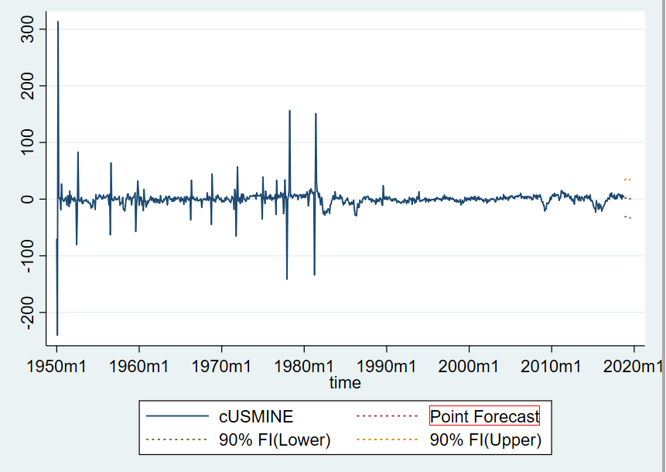

**Here we cut off at 2000m1 to get a better look at our forecasts**

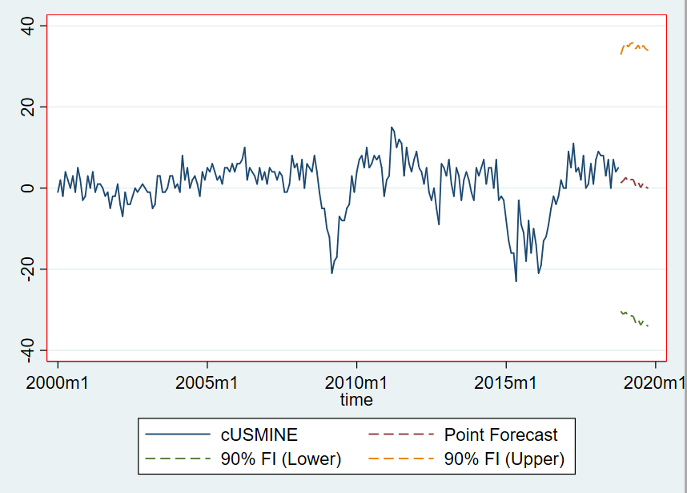

Lastly we converted our changes forecast back into levels as we have done many times in class. The result of said conversion are shown in the following two graphs.

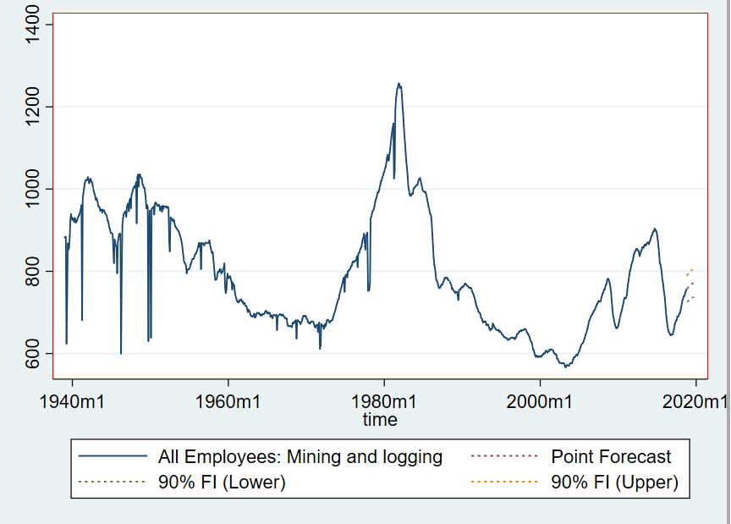

**And again we cut off the graph at 2000m1 to get a better look at our forecasts**

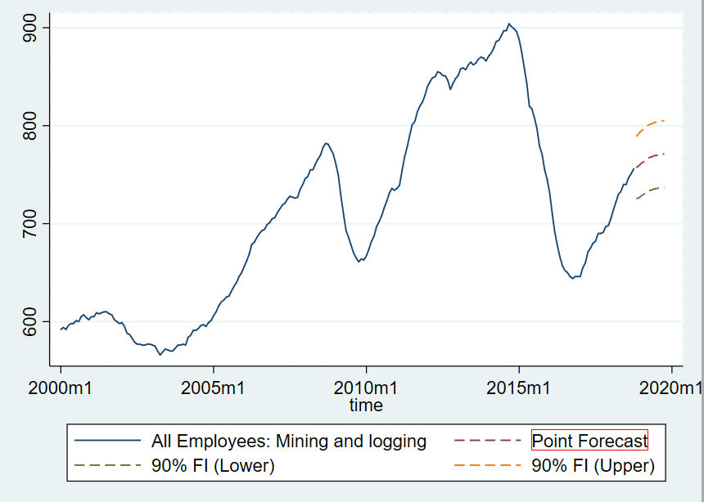

In the end, we forecasted that US Mining and Logging employment will be **757,265** people with the 90% confidence intervals of **[725,655, 788,874]**. There a couple things to note about our forecast. Firstly, we saw some fairly large standard errors which are responsible for the somewhat wide confidence intervals one can observe above. This can be attributed to the large spikes in the data, seen towards the earlier dates of our sample (Figure 7).

However, what is most interesting about our forecast is that it predicts a decline in the pace of coal jobs in the upcoming horizons. Even stronger, it appears the we will be forecasting a decline in the number of US mining and logging jobs in just a few horizons after the 12 we forecasted. We found this result pretty interesting, and maybe even comforting. We believe that the general intuition is that we should be trying to move away from coal mining and other industries fueled fossil fuels to more renewable sources of energy. The data does show a clear insurgence in the amount of mining and logging jobs, surely brought on by a certain political leader in the last couple of years. However, our forecasts suggest that scientific consensus will prevail and we will revert back to the dated notion that coal jobs might not be the in the best interest for future Americans.

**Figures**

**FIGURE 1.**

Augmented Dickey-Fuller test for unit root Number of obs = 945

---------- Interpolated Dickey-Fuller ---------

Test 1% Critical 5% Critical 10% Critical

Statistic Value Value Value

------------------------------------------------------------------------------

Z(t) -2.380 -3.430 -2.860 -2.570

------------------------------------------------------------------------------

MacKinnon approximate p-value for Z(t) = 0.1475

**FIGURE 2.**

Augmented Dickey-Fuller test for unit root Number of obs = 944

---------- Interpolated Dickey-Fuller ---------

Test 1% Critical 5% Critical 10% Critical

Statistic Value Value Value

------------------------------------------------------------------------------

Z(t) -8.206 -3.430 -2.860 -2.570

------------------------------------------------------------------------------

MacKinnon approximate p-value for Z(t) = 0.0000

**Figure 3.**

( 1) L.cPCEENERGY = 0

( 2) L2.cPCEENERGY = 0

( 3) L3.cPCEENERGY = 0

( 4) L4.cPCEENERGY = 0

( 5) L5.cPCEENERGY = 0

( 6) L6.cPCEENERGY = 0

( 7) L7.cPCEENERGY = 0

( 8) L8.cPCEENERGY = 0

( 9) L9.cPCEENERGY = 0

(10) L10.cPCEENERGY = 0

(11) L11.cPCEENERGY = 0

(12) L12.cPCEENERGY = 0

F( 12, 680) = 6.26

Prob > F = 0.0000

**FIGURE 4.**

Akaike's information criterion and Bayesian information criterion

-----------------------------------------------------------------------------

Model | Obs ll(null) ll(model) df AIC BIC

-------------+---------------------------------------------------------------

model00 | 705 -2860.269 -2860.269 1 5722.538 5727.096

model10 | 705 -2860.269 -2853.71 2 5711.42 5720.536

model30 | 705 -2860.269 -2849.331 4 5706.663 5724.896

model60 | 705 -2860.269 -2840.066 7 5694.133 5726.04

model120 | 705 -2860.269 -2831.432 13 5688.863 5748.12

model01 | 705 -2860.269 -2859.454 2 5722.908 5732.024

model11 | 705 -2860.269 -2853.063 3 5712.127 5725.801

model31 | 705 -2860.269 -2848.643 5 5707.287 5730.078

model61 | 705 -2860.269 -2839.37 8 5694.74 5731.206

model121 | 705 -2860.269 -2830.783 14 5689.566 5753.381

model06 | 705 -2860.269 -2848.369 7 5710.737 5742.645

model16 | 705 -2860.269 -2844.177 8 5704.353 5740.819

model36 | 705 -2860.269 -2839.741 10 5699.483 5745.065

model66 | 705 -2860.269 -2830.425 13 5686.851 5746.107

model126 | 705 -2860.269 -2821.295 19 5680.59 5767.196

model012 | 705 -2860.269 -2839.039 13 5704.079 5763.335

model112 | 705 -2860.269 -2836.596 14 5701.192 5765.007

model312 | 705 -2860.269 -2831.766 16 5695.533 5768.464

model612 | 705 -2860.269 -2823.404 19 5684.807 5771.413

model1212 | 705 -2860.269 -2815.859 25 5681.719 5795.674

-----------------------------------------------------------------------------

Note: N=Obs used in calculating BIC; see [R] BIC note.

* **modelpq -> p AR lags, q regressor lags**
* **YELLOW are the four lowest AIC’s**
* **BLUE are the three remaining forecasts after using the Granger Ramanathan Combination method**

**FIGURE 5.**

. constraint 4 y06 + y012 + y13 + y16 + y112 + y30 + y33 + y36 + y312 + y63 + y612 + y120 + y121 + y123 + y126 +y1212 = 1

. cnsreg cUSMINE y06 y012 y13 y16 y112 y30 y33 y36 y312 y63 y612 y120 y121 y123 y126 y1212, constraints(4) noconstant

Constrained linear regression Number of obs = 164

Root MSE = 4.0755

( 1) y06 + y012 + y13 + y16 + y112 + y30 + y33 + y36 + y312 + y63 + y612 + y120 + y121 + y123 + y126 + y1212 = 1

------------------------------------------------------------------------------

cUSMINE | Coef. Std. Err. t P>|t| [95% Conf. Interval]

-------------+----------------------------------------------------------------

y06 | -8.289163 1.773662 -4.67 0.000 -11.79394 -4.784383

y012 | 4.09313 1.769161 2.31 0.022 .5972454 7.589015

y13 | 3.060428 3.952436 0.77 0.440 -4.749639 10.87049

y16 | 6.464397 4.032737 1.60 0.111 -1.504345 14.43314

y112 | -2.109154 2.207328 -0.96 0.341 -6.470865 2.252556

y30 | 1.135205 2.196954 0.52 0.606 -3.206006 5.476416

y33 | 7.830581 8.325251 0.94 0.348 -8.620225 24.28139

y36 | -12.33186 8.138492 -1.52 0.132 -28.41363 3.749906

y312 | 1.181474 1.594881 0.74 0.460 -1.970032 4.33298

y63 | 1.205311 1.82592 0.66 0.510 -2.402732 4.813354

y612 | -2.257973 1.527535 -1.48 0.141 -5.276403 .7604571

y120 | -.757706 2.433245 -0.31 0.756 -5.56583 4.050418

y121 | -.3440236 .2536781 -1.36 0.177 -.8452948 .1572477

y123 | -12.53281 5.403744 -2.32 0.022 -23.21068 -1.854936

y126 | 15.62325 5.244241 2.98 0.003 5.260563 25.98594

y1212 | -.9710919 .8864134 -1.10 0.275 -2.722656 .7804725

------------------------------------------------------------------------------

* **modelpq -> p AR lags, q regressor lags**

**FIGURE 6.**

Constrained linear regression Number of obs = 164

Root MSE = 4.8600

( 1) y112 + y120 + y126 = 1

------------------------------------------------------------------------------

cUSMINE | Coef. Std. Err. t P>|t| [95% Conf. Interval]

-------------+----------------------------------------------------------------

y112 | .5738973 .0708411 8.10 0.000 .4340063 .7137882

y120 | .3824363 .0550893 6.94 0.000 .2736505 .4912221

y126 | .0436664 .0852128 0.51 0.609 -.1246047 .2119374

------------------------------------------------------------------------------

* **modelpq -> p AR lags, q regressor lags**

**FIGURE 7**

